Assessment Schedule – 2016
Physics: Demonstrate understanding of aspects of wave behaviour (90938)
Evidence Statement
Question | Evidence | Achievement | Merit | Excellence
ONE  (a) | Longitudinal (any valid example)  - seismic waves  - sound waves  - slinky stretched then released.  Transverse (any valid example)  - any radiation in the EM spectrum  - water waves (more circular than transverse – but acceptable example)  - seismic waves  - waves on a string / rope. | BOTH examples correct.
(b) | Longitudinal  - Particles vibrate in the same direction / parallell as the propagation.  - Travel by compression and rarefaction.  Transverse  - Particles vibrate perpendicular to the direction of movement.  - Travel by the crest and troughs. | States how the particles move in both types of wave. | Explains particle motion and wave propagation for both types of wave.
(c)(i)  (ii) | See Appendix for diagram of one acceptable answer. Amplitude can be any reference from the equilibrium line to a crest OR trough.  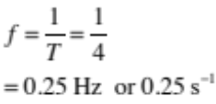 | Diagram has amplitude correct.  OR  Correct calculation of frequency. | Diagram is complete and frequency is calculated correctly with unit.
(d)(i)  (ii) | 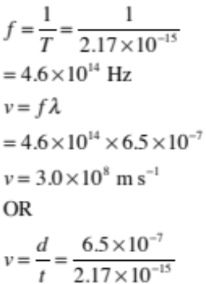  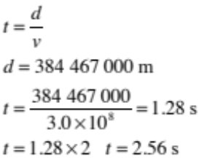 | Correctly solves for f (i).  OR  Solves for velocity of light using 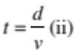  Uses 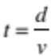 without converting distance from km into m  (1.28 × 10^{–3} s).  OR  Attempts to find time, but fails to account for distance × 2 and therefore getting time as  t = 1.28 s) | Solves for velocity of light.  AND  Attempts to find time but fails to account for distance × 2 (and therefore getting time as t = 1.28 s).  OR  Doubling incorrect time (2.56 × 10^{–3} s)  OR  Incorrectly / doesn’t solve for velocity of light  AND  Correctly calculates time for laser to return as 2.56 s | Solves for velocity of light  AND  Correctly calculates time for laser to return as 2.56 s.

NØ | N1 | N2 | A3 | A4 | M5 | M6 | E7 | E8
No relevant evidence. | Very little evidence at Achievement level. Most evidence is at the Not Achieved level. | Some evidence at Achievement level; partial explanations. | Most evidence provided is at Achievement level, while some is at the Not Achieved level. | Nearly all evidence provided is at the Achievement level. | Some evidence is at the Merit level with some at the Achievement level. | Most evidence is at the Merit level, with some at the Achievement level. | Evidence is provided for most tasks, with evidence at the Excellence level weak or with minor errors / omissions. | Evidence provided for all tasks. Evidence at the Excellence level accurate and full.
0 | 1A | 2A | 3A | 4A | 1A + 2M | 2A + 2M | 2M + 1E | 1A + 2M + 1E

Question |  | Achievement | Merit | Excellence
TWO  (a) | See Appendix for diagram. | Drawn with waves diffracting around the island edge. | Drawn with wavelength remaining constant and even curvature of the top and bottom waves, clear indication that no waves are directly behind the small island.
(b) (i)  (ii) | Kayaker goes behind the small island because as the waves diffract around the island, they leave an area behind the island that is flat and which creates a safe area for the kayaker. The wavelength of the waves s such that the amount of diffraction is not enough to reach the kayaker  Calculates the period: 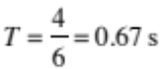 | Statement of safety for kayaker.  OR  Calculation correct. | Waves don’t reach Kayaker or area of calm water created.  OR  Correct period. | Amount of diffraction linked to wavelength  AND  Correct period
(c) | See Appendix for diagram. | Shows the refraction of white light through the prism but order incorrect.  OR  Correct order. | Shows the refraction of the white light with r being least refracted and v being most.
(d) | White light is made up of ROYGBIV, each with a differing wavelength and frequency.  Red light has a lower frequency (and longer wavelength) than blue light. Blue has a higher frequency (and shorter wavelength) than red light.  The prism has an optical density, which changes the speed at which the light is travelling. The optical density is dependent on the frequency of light.  The speed at which the light is travelling differs between red and blue. Blue travels more slowly in the prism (higher frequency, higher optical density, slower speed) so its path becomes more deviated than the red light. | Describes the idea of each colour having a different wavelength or frequency. | Explains the idea of each of red and blue light changing speed as they enter a new medium of the prism. | Relates a frequency to the changing speed and optical density of the medium, thus explaining how blue travels more slowly, so its path is more deviated than the red light.

NØ | N1 | N2 | A3 | A4 | M5 | M6 | E7 | E8
No relevant evidence. | Very little evidence at the Achievement level. Most evidence is at the Not Achieved level. | Some evidence at the Achievement level; partial explanations. | Most evidence provided is at the Achievement level, while some is at the Not Achieved level. | Nearly all evidence provided is at the Achievement level. | Some evidence is at the Merit level with some at the Achievement level. | Most evidence is at the Merit level, with some at the Achievement level. | Evidence is provided for most tasks, with evidence at the Excellence level weak or with minor errors / omissions. | Evidence provided for all tasks. Evidence at the Excellence level accurate and full.
0 | 1A | 2A | 3A | 4A | 1A + 2M | 2A + 2M | 2M + 1E  Must have E | 1A + 2M + 1E

Question | Evidence | Achievement | Merit | Excellence
THREE  (a)(i) | See Appendix. | One ray drawn correctly with a dotted line for a virtual ray. | Two rays drawn correctly with the image drawn in approximate correct position.
(ii) (iii) | See Appendix. | Angle of incidence and angle of reflection correctly labelled  OR  States that θ_{i} = θ_{r}
(b) | In the night-time position, a large percentage of the light is refracted into the glass wedge. This light is then reflected off the mirror at a greater angle than usual and travels to the front of the glass wedge again. Here it refracts into the air, and is travelling at an angle that does not enter the driver’s eye. Some of the light is also reflected back into the glass, again away from the driver. | - Light refracts at first contact  OR  Light reflects off mirror  OR  - Light refracts out of glass away from driver/eye.  OR  - Light (partially) reflects back into glass | TWO of Achievement bullets out of four. | THREE of Achievement bullets out of four.  Talking about TIR at last interface negates E8.
(c) | Total Internal Reflection.  Ray One is travelling in glass, which is a more optically dense medium, and is reaching a boundary with air that is less optically dense. The ray is also reaching this boundary at an angle greater than the ‘critical angle’. Both of these conditions will mean that the ray will undergo TIR. | States that Ray One is undergoing Total Internal Reflection. | States TIR and gives the conditions of TIR.  The angle of light is greater than the critical angle.  The glass is more optically dense than then air / light slower in glass or faster in air

NØ | N1 | N2 | A3 | A4 | M5 | M6 | E7 | E8
No relevant evidence. | Very little evidence at the Achievement level. Most evidence is at the Not Achieved level. | Some evidence at the Achievement level; partial explanations. | Most evidence provided is at the Achievement level, while some is at the Not Achieved level. | Nearly all evidence provided is at the Achievement level. | Some evidence is at the Merit level with some at the Achievement level. | Most evidence is at the Merit level, with some at the Achievement level. | Evidence is provided for most tasks, with evidence at the Excellence level weak or with minor errors / omissions. | Evidence provided for all tasks. Evidence at the Excellence level accurate and full.
0 | 1A | 2A | 3A | 4A | 1A + 2M | 2A + 2M | 2M + 1E | 1A + 2M + 1E

Cut Scores
Not Achieved | Achievement | Achievement with Merit | Achievement with Excellence
0 – 6 | 7 – 13 | 14 – 19 | 20 – 24

Appendix of Diagrams

Question One (c)(i)

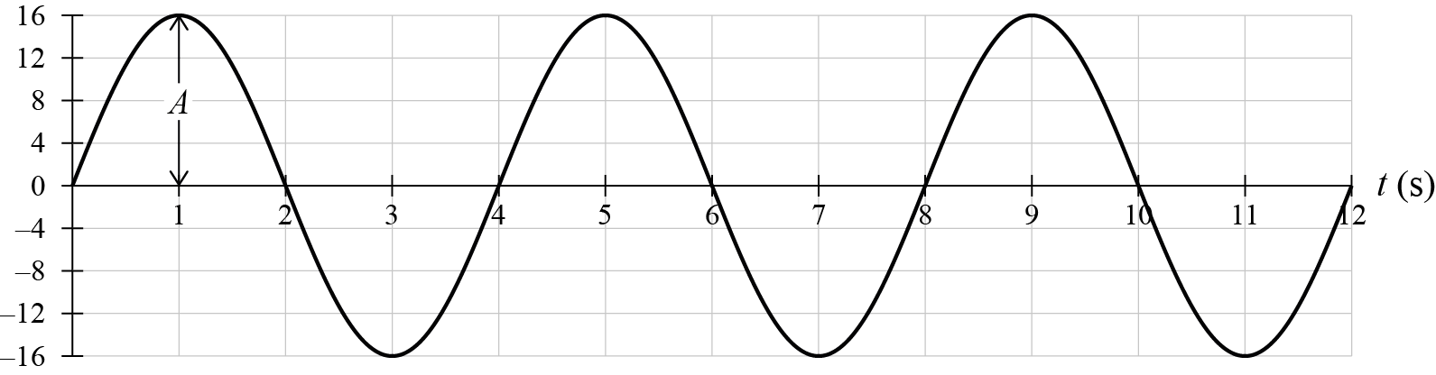

Question Two (a)

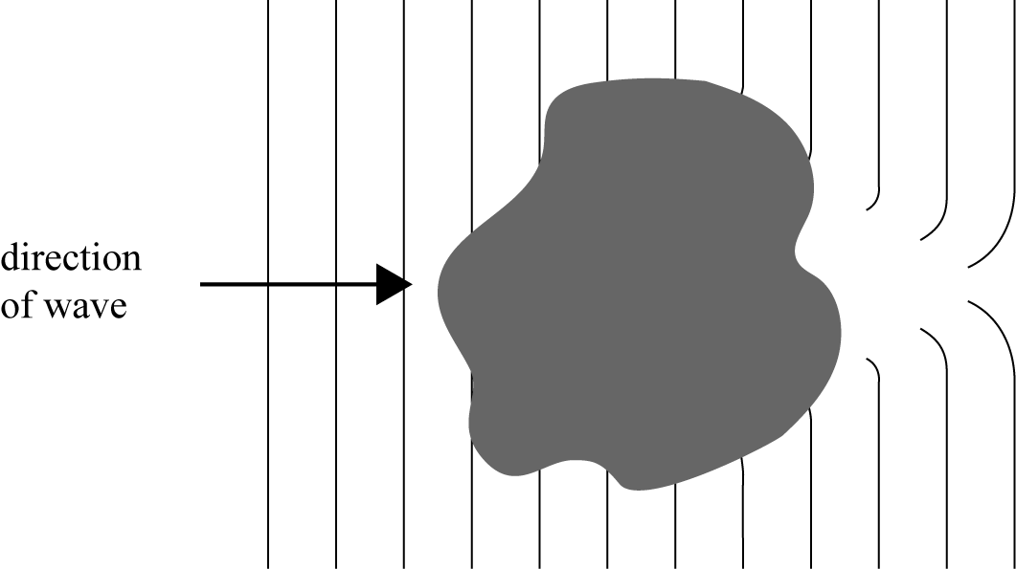

Question Two (c)

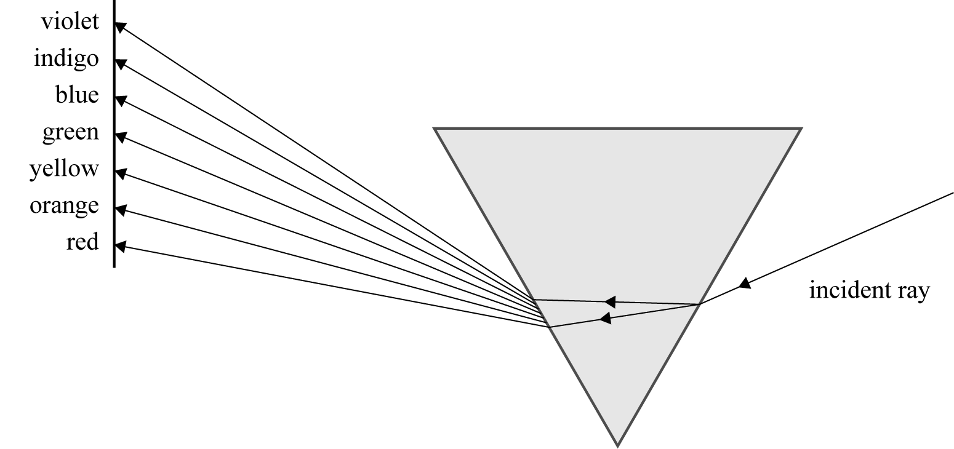

Question Three (a)
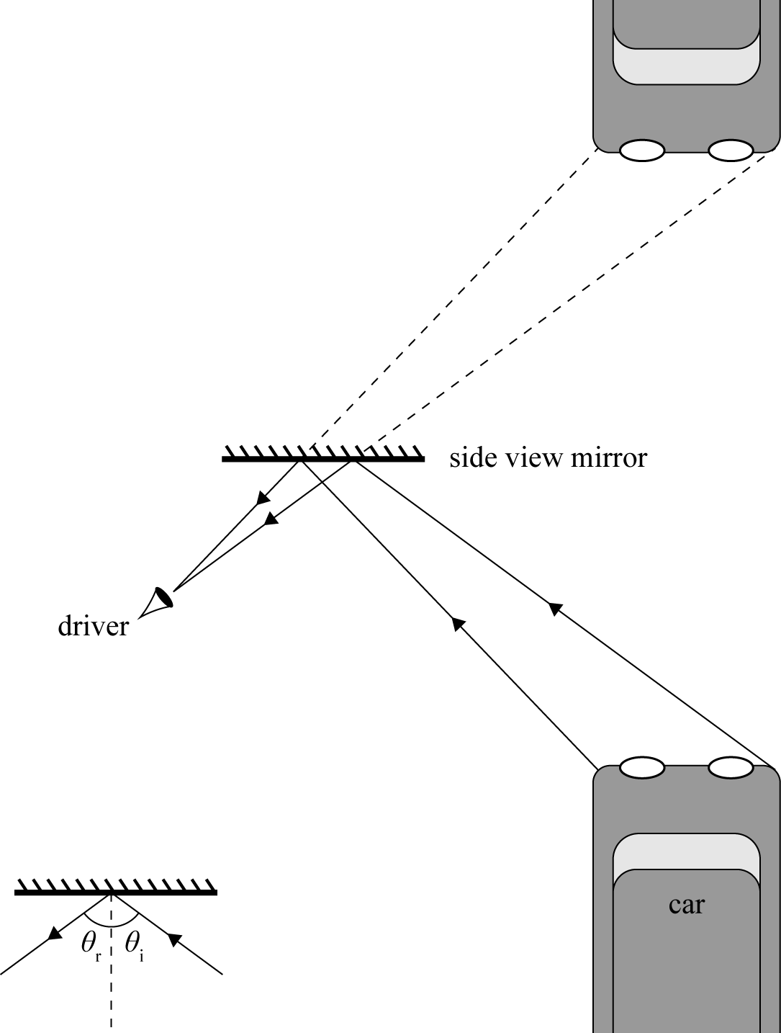

OR

